**Hello Team Officials,**

We are excited to announce that we have reached **340 teams** for our **56th Annual Tournament!** The event will feature **34 divisions, 12 venues, and 757 games played on 25 sheets of ice.** Thank you for your support!

**Tournament Information**

* **Tournament Headquarters**: Room #2, Century Gardens Arena, 340 Vodden Street East, Brampton, ON L6V-2N2.
* **2025 Tournament Schedule**: Now available in the **Documents Section** of the main event page.
* **Official Website**:  [**Sportacular Event Portal**](https://www2.sportacularevent.com/portal/events/event/115) (Please do not contact arenas or the city for scores). If you find what you believe as an incorrect score, please notify us via email – to expedite inquiries please in subject line use: Concern the division and GM# - then share your concern. Saturday is a very busy day for advancing teams. We have a process which identifies which divisions have to be advanced in a chronological process. Many inquiries are made and the pool or divisions has not completed their final RR games in order for us to calculate and advance teams. We appreciate everyone’s patience.
* The 2025 Schedule is now posted in the document section of the main event page
* Teams ***Do Not*** have to register at Headquarters
* Team Ramp Game Codes will be made available once everything is uploaded. The OWHA is still populating divisions in the Tournament link, so please remain patient
* **Final Team Spot Available**: We are looking for **one final team** for U9A, 18AA, 18HL, SRA, SRB, or 22A. If you know of an available team, have them contact us directly.

**Team Roster Submission**

* Official PDF Rosters MUST be uploaded to your **Sportacular Events account.**
* Mandatory request for all teams - Log in to your Sportacular Event Acct, go to **MY TEAMS**, select your registered team, and click **EDIT** to update your roster and bench staff to ensure correct contact information is correct. Players only require jersey# and name.
* *Yes, it needs to be manually typed in for the information below*
* Be sure to save your updates to ensure accuracy for game sheets
* A single-page game sheet system is used for consistency between ice-level officials and administration.
* You may now also as shown where to Upload your teams official PDF roster.

**2025 Tournament Updates**

* **"Player of the Game" awards** will be given for every game pickup at Arena Convenor Table in lobby you will sign for the award.
* Special **Finals** Player of the Game award is a commemorate gold medal
* **Championship Finals**: Winners receive Gold Medals and an Arena Banner; finalists receive Silver Medals.
* **New Awards**: Same as Player of game awards, if a player has a Hat Trick or Shutout
  + "Wholly Moly Who's That Goalie" Shutout Awards
  + "Holy Hat Trick" Awards for players scoring a hat trick

**Game Scores & Notifications**

* **Free Text Notifications**: Team Staff and Managers along with a Mandatory of **four team members** must sign up for real-time game scores and advancement notifications. Once round-robin games are completed, and rankings are finalized notifications will be sent with game details. These will be shared in a separate email.
* Notifications will include your **next game time, arena, and opponent**. We use this also for any Emergency issues and or to broadcast game changes etc.
* **Incorrect Scores**: Report any discrepancies via email during the event at [info@sportacularevents.com](mailto:info@sportacularevents.com) with the game number your teams division and name.
* **Backup Plan**: If internet services go down, a backup website will be released for accessing scores
* Additional updates on **vendor specials, silent auctions, and event reminders**.

**Important Rules & Reminders**

* **Player Eligibility**: Players can only compete with one team in one tournament during the weekend
* **Pickup Players**: Any team using an OWHA Pickup Players must follow these rules or face Forfeiture and or Suspensions and fines.
* **Any team Found to be using an illegal player or playing suspended players will be removed from the tournament and any further games will results in Game Forfeitures.** **The OWHA Will also be notified as required**
* **Rep Teams**: Allowed **max 3** replacements but cannot replace suspended players. Rep teams may only use Players from below levels of play – No Lateral Callups even if playing up in a combined division. If a team has been found to use an illegal callup or player the team will be removed from the event
* **DS Teams**: DS Players must play on their rostered team and are not allowed to play with 2 teams in the same event. Cannot use call-up players but can rotate within their official roster.
* **HL/LL Teams**: Allowed **max 3** players to replace 3 existing players on their official roster. Must use lateral players (e.g., U15HL can use U15HL or lower). Cannot replace suspended players.
* **ALL** Teams cannot exceed their official roster limit at any time.
* **Equipment Rules**:
* **USA Teams**: Mandatory **mouthguards** (per USA Hockey Insurance).
* **Canadian Teams**: Mandatory **BNQ neck guards** (per Hockey Canada)
* **Suspensions**: Hockey Canada and OWHA SUSPENSION rules shall apply where required. All suspensions must be reported to **OWHA** via email and await their direction as to number of games. You must comply. Clearance must be received before returning to play. Teams from out of Province will be notified of IF a member of team is under suspension
* **Travel Permits**: All out-of-province teams must submit their travel permits and email to Sportacular Events. If Travel permit is not provided the team is not allowed to play it’s a Hockey Canada Insurance Rule
* **Rosters**: Have a copy of your roster available in the event of any discrepancy
* **Tournament Rules**: Posted live on the Sportacular site. Please also note we do not use GF/GA we instead use the Tie Breaker Calculator chart in the document sections.

**Game Day Procedures**

* **Jersey Color Conflicts**: Teams should bring an extra set of jerseys or pinnies to avoid conflicts.
* **Championship Awards & Photos**: Arena banners and medals will be awarded **off the ice** due to safety and insurance regulations
* **Dressing Rooms**:
  + Bring your own lock where required.
  + Keep rooms clean before vacating.
* **Game Start Times**: Games may begin up to **20 minutes early** based on arena convenor coordination
* **Check-in Requirements**: Team managers or head coaches should check in with arena convenor in lobby before each game. You do not need to check in a headquarters.

**Please Note that at SUE FENNELL due to congestion in main arena lobby the Convenor table will be in the foyer directly in front of the attached Library on site

* **Player of the Game Award**: A player of the game skate towel will be provided at the sign in table prior to the start of each game and awarded by the coach
* **Shutout/Hatrick Awards:** Available at the convenor table at the end of your game
* **Identifying Event Staff**: Sportacular Event Staff will wear red jackets with “Event Staff on the bank. Ask for help at any game sheet sign-in area
* **RAMP Game Codes**: Will be emailed and also available at game sheet convenor tables.

**Final Notes**

* **2025 Tournament Rules** go live on **April 9**.
* Updates regarding **HL jersey color conflicts** and the **U7 Future Stars itinerary** will be shared soon.
* A **Vendor Listing** will be posted before the event.
* If we promised thank-you or incentives items, please remind us before the first game so we have them ready for you.

We look forward to seeing you all in **two weeks!** Check the **event main page** for ongoing updates.

**Thank you, and best of luck to all teams!**

**2025 Brampton Easter Tournament Vendors**

Century Gardens – Silent Auction Location

*Northwest Designs Event Clothing

*Sona Flood

*Grindstone Award Foundation

Susan Fennell

*Northwest Designs Event Clothing

*S & L Charms

CAA Centre

*Northwest Designs Event Clothing

*Busy Beads

Paramount

*PWHL

Meadowvale

*PWHL

*Authentic Memories Team and Action Photos

Iceland

* Northwest Designs Event Clothing

*Authentic Memories Team and Action Photos

*Busy Beads

*Harly Imports & Toys

*The 88 Hair Tie

**WELCOME TO THE "BRAMPTON CANADETTES EASTER TOURNAMENT" PHOTO PACKAGE!**

**(see attached-all prices include tax)**

 WE DO **NOT** TAKE**RANDOM** PHOTOS- ACTION PHOTOS BY REQUEST ONLY-  
(SET-UPS WILL BE **" ICELAND AND MEADOWVALE 4-RINKS"** - BUT ROVER "SHOOTERS" AVAILABLE-**IF BOOKED IN ADVANCE)**

  1**) TEAM LOCKER PHOTO**: (PLEASE BOOK APPT- NO OBLIGATION TO PURCHASE)

    see sample attached  
    (13 x 19 photo) - **$45** ea - or 7 or more - **$35 ea**

**FRAME  ADDITIONAL- $40**(limited number of frames available )

* **no obligation** to try -sample will be created and image given to manager PLUS put on display for parents to view

**SEE DETAILS BELOW / ATTACHED FOR EVENT SPECIAL!!- $25 OFFER AVAILABLE !!**

* please contact Eric (below) to reserve a time-

**2) TEAM ACTION PHOTOS: (DIGITAL IMAGES ARE EMAILED TO MANAGER)**

**OPTION A: $250**per game (approx 150 - 200 images)

**OPTION B:-$350**-FOR TWO GAMES (approx 400-500 images!!!)

***PRE- BOOK SPECIAL- FIRST 6 TEAM TO BOOK EITHER ACTION PHOTO PACKAGE- DEDCUT $50***

(PLEASE BOOK (and pay) PRIOR THE EVENT)- So I can schedule the proper number of PROFESSIONAL photographers

Please note- Team photo image is **NOT**included in Action Photo Package

**3) NEW FOR 2025!- 2 IMAGE COMPOSITE- $140- INCLUDES FRAME AND PHOTO**

 (NOTE:- IF YOUR TEAM DOES NOT BOOK AN ACTION PHOTO PACKAGE- PLEASE LET YOUR PARENTS KNOW THEY NEED TO REQUESTS PHOTOS- **NO RANDOM SHOTS!**)

Thank you and if you have any questions or special requests- please let me know

Good Luck

**Eric Niskanen-416-579-1845**  
[**eric.niskanen**](http://eric.niskanen/)**@**[**sympatico.ca**](http://sympatico.ca/)

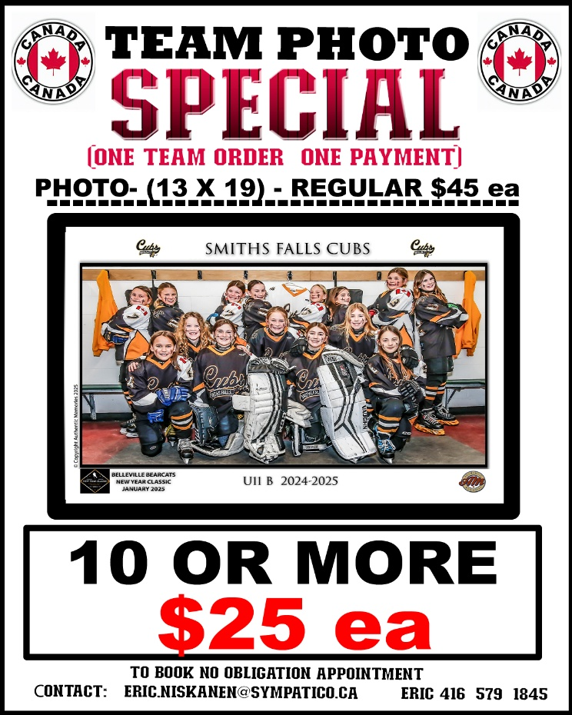 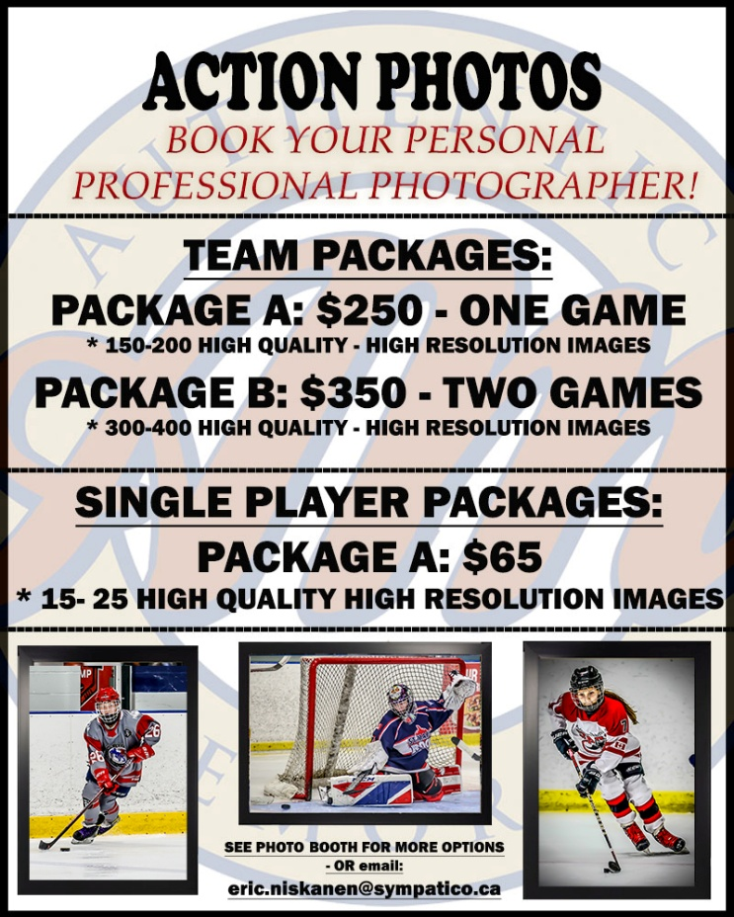



**Tournament Special – Exclusive Group Offer 🏒**

To celebrate and welcome all teams participating in the Easter Hockey Tournament, we're excited to offer an exclusive deal:

**✨ $25 off every group booking  
✨ Plus, enjoy 10% off your entire bill**

To redeem this offer, simply book through our OpenTable links below or call ahead to reserve.

Be sure to mention the *Easter Hockey Tournament* when booking.

**This offer is available at the following Moxies locations:**

* Courtney park [RESERVE HERE](https://www.opentable.ca/r/moxies-courtney-park-mississauga)
* Argentia [RESERVE HERE](https://www.opentable.ca/r/moxies-argentia-mississauga)
* Square One [RESERVE HERE](https://www.opentable.ca/r/moxies-square-one-mississauga)

Whether you're fueling up before a big game or winding down with the team, we’re here to make your visit special.

We can’t wait to serve you — good luck out there!

Matt Mesurier

Regional Manager - Moxies PCL



**Tandoori Flame Restaurant - North America's Largest Indian Buffet & Restaurant**

8150 Dixie Rd., Brampton, ON  
(905) 451-1686

[www.tandooriflame.com](http://www.tandooriflame.com/)

1. 15% discount
2. Three coaches are free with a team of 15 or more players.

Thanks to their general manager - Manoj Kumar